Практическая работа №4
Тема: «Построение Машины вывода для Экспертной
Системы реляционного типа»

Цель: разработать модель экспертной системы, реализующей механизм вывода на основе реляционной базы знаний, для определения погодных условий в заданных городах в Windows Forms.

Ход работы
- Дизайн нашей программы
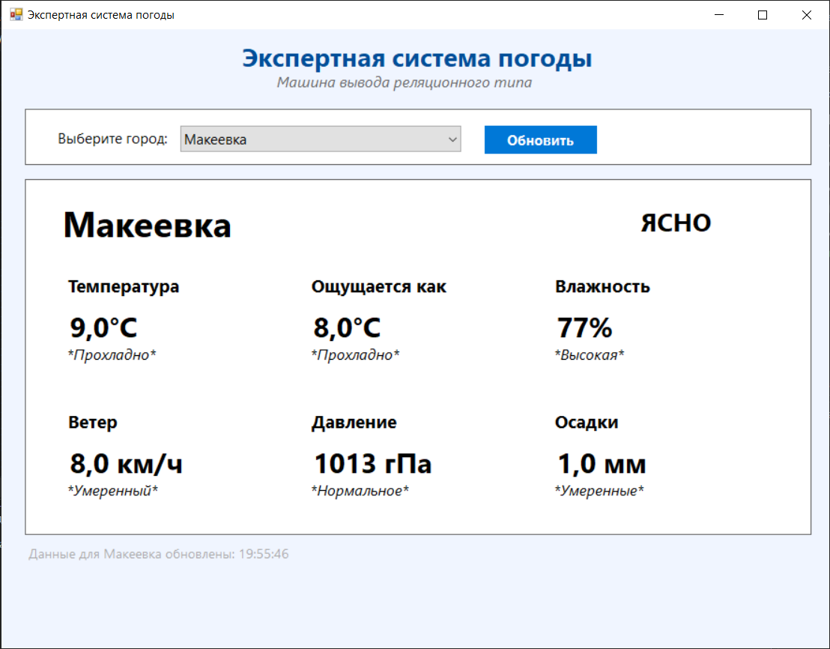
- Код нашей программы
using System;
using System.Drawing;
using System.Windows.Forms;
using System.Net.Http;
using System.Threading.Tasks;
using Newtonsoft.Json.Linq;
using System.Collections.Generic;

namespace WeatherExpertSystem
{
public partial class Form1 : Form
{
private Dictionary<string, (double lat, double lon)> cities = new Dictionary<string, (double, double)>
{
{ "Макеевка", (48.0636, 38.0618) },
{ "Донецк", (48.0159, 37.8028) },
{ "Ростов", (47.2313, 39.7233) },
{ "Москва", (55.7558, 37.6173) },
{ "Санкт-Петербург", (59.9343, 30.3351) }
};

private HttpClient httpClient;
private Dictionary<string, Label> valueLabels = new Dictionary<string, Label>();
private Dictionary<string, Label> assessmentLabels = new Dictionary<string, Label>();

private ComboBox comboBoxCities;
private Label lblCityName;
private Label lblWeatherState;
private Label lblUpdateTime;

public Form1()
{
InitializeComponent();
InitializeCustomComponents();
InitializeHttpClient();
Load += Form1_Load;
}

private void InitializeHttpClient()
{
httpClient = new HttpClient();
httpClient.Timeout = TimeSpan.FromSeconds(10);
httpClient.DefaultRequestHeaders.Add("User-Agent", "WeatherExpertSystem/1.0");
}

private async void Form1_Load(object sender, EventArgs e)
{
await InitializeData();
}

private async Task InitializeData()
{
comboBoxCities.SelectedItem = "Макеевка";
await UpdateWeatherData("Макеевка");
}

private void InitializeCustomComponents()
{
this.Text = "Экспертная система погоды";
this.Size = new Size(900, 700);
this.StartPosition = FormStartPosition.CenterScreen;
this.BackColor = Color.FromArgb(240, 245, 255);
this.Padding = new Padding(20);

Label titleLabel = new Label();
titleLabel.Text = "Экспертная система погоды";
titleLabel.Font = new Font("Segoe UI", 20, FontStyle.Bold);
titleLabel.ForeColor = Color.FromArgb(0, 78, 152);
titleLabel.AutoSize = true;
titleLabel.Location = new Point(250, 10);
this.Controls.Add(titleLabel);

Label subtitleLabel = new Label();
subtitleLabel.Text = "Машина вывода реляционного типа";
subtitleLabel.Font = new Font("Segoe UI", 12, FontStyle.Italic);
subtitleLabel.ForeColor = Color.FromArgb(100, 100, 100);
subtitleLabel.AutoSize = true;
subtitleLabel.Location = new Point(290, 45);
this.Controls.Add(subtitleLabel);

Panel cityPanel = new Panel();
cityPanel.BackColor = Color.White;
cityPanel.BorderStyle = BorderStyle.FixedSingle;
cityPanel.Size = new Size(840, 60);
cityPanel.Location = new Point(25, 85);
this.Controls.Add(cityPanel);

Label citySelectLabel = new Label();
citySelectLabel.Text = "Выберите город:";
citySelectLabel.Font = new Font("Segoe UI", 11, FontStyle.Regular);
citySelectLabel.Location = new Point(30, 20);
citySelectLabel.AutoSize = true;
cityPanel.Controls.Add(citySelectLabel);

comboBoxCities = new ComboBox();
comboBoxCities.Name = "comboBoxCities";
comboBoxCities.Font = new Font("Segoe UI", 11);
comboBoxCities.DropDownStyle = ComboBoxStyle.DropDownList;
comboBoxCities.Location = new Point(165, 17);
comboBoxCities.Size = new Size(300, 28);
comboBoxCities.MaxDropDownItems = 10;
foreach (var city in cities.Keys)
{
comboBoxCities.Items.Add(city);
}
comboBoxCities.SelectedIndexChanged += async (s, e) =>
{
if (comboBoxCities.SelectedItem != null)
{
await UpdateWeatherData(comboBoxCities.SelectedItem.ToString());
}
};
cityPanel.Controls.Add(comboBoxCities);

Button updateButton = new Button();
updateButton.Name = "btnUpdate";
updateButton.Text = "Обновить";
updateButton.Font = new Font("Segoe UI", 11, FontStyle.Bold);
updateButton.BackColor = Color.FromArgb(0, 120, 215);
updateButton.ForeColor = Color.White;
updateButton.FlatStyle = FlatStyle.Flat;
updateButton.FlatAppearance.BorderSize = 0;
updateButton.Size = new Size(120, 30);
updateButton.Location = new Point(490, 17);
updateButton.Cursor = Cursors.Hand;
updateButton.Click += async (s, e) =>
{
if (comboBoxCities.SelectedItem != null)
{
await UpdateWeatherData(comboBoxCities.SelectedItem.ToString());
}
};
cityPanel.Controls.Add(updateButton);

Panel weatherPanel = new Panel();
weatherPanel.Name = "weatherPanel";
weatherPanel.BackColor = Color.White;
weatherPanel.BorderStyle = BorderStyle.FixedSingle;
weatherPanel.Size = new Size(840, 380);
weatherPanel.Location = new Point(25, 160);
this.Controls.Add(weatherPanel);

lblCityName = new Label();
lblCityName.Name = "lblCityName";
lblCityName.Text = "Макеевка";
lblCityName.Font = new Font("Segoe UI", 28, FontStyle.Bold);
lblCityName.ForeColor = Color.Black;
lblCityName.AutoSize = true;
lblCityName.Location = new Point(30, 20);
weatherPanel.Controls.Add(lblCityName);

lblWeatherState = new Label();
lblWeatherState.Name = "lblWeatherState";
lblWeatherState.Text = "ЯСНО";
lblWeatherState.Font = new Font("Segoe UI", 20, FontStyle.Bold);
lblWeatherState.ForeColor = Color.Black;
lblWeatherState.AutoSize = true;
lblWeatherState.Location = new Point(650, 25);
weatherPanel.Controls.Add(lblWeatherState);

int totalCardsWidth = 3 * 240 + 2 * 20;
int startX = (weatherPanel.Width - totalCardsWidth) / 2;

int startY = 90;
int cardWidth = 240;
int cardHeight = 120;
int horizontalSpacing = 20;
int verticalSpacing = 25;

CreateWeatherCard(weatherPanel, "Температура", "9,0°C", "Прохладно",
startX, startY, cardWidth, cardHeight, "temperature");
CreateWeatherCard(weatherPanel, "Ощущается как", "8,0°C", "Прохладно",
startX + cardWidth + horizontalSpacing, startY, cardWidth, cardHeight, "feelsLike");
CreateWeatherCard(weatherPanel, "Влажность", "77%", "Высокая",
startX + 2 * (cardWidth + horizontalSpacing), startY, cardWidth, cardHeight, "humidity");

int secondRowY = startY + cardHeight + verticalSpacing;
CreateWeatherCard(weatherPanel, "Ветер", "8,0 км/ч", "Умеренный",
startX, secondRowY, cardWidth, cardHeight, "wind");
CreateWeatherCard(weatherPanel, "Давление", "1013 гПа", "Нормальное",
startX + cardWidth + horizontalSpacing, secondRowY, cardWidth, cardHeight, "pressure");
CreateWeatherCard(weatherPanel, "Осадки", "1,0 мм", "Умеренные",
startX + 2 * (cardWidth + horizontalSpacing), secondRowY, cardWidth, cardHeight, "precipitation");

lblUpdateTime = new Label();
lblUpdateTime.Name = "lblUpdateTime";
lblUpdateTime.Text = "Данные для Макеевка обновлены: 19:55:46";
lblUpdateTime.Font = new Font("Segoe UI", 10, FontStyle.Regular);
lblUpdateTime.ForeColor = Color.DarkGray;
lblUpdateTime.AutoSize = true;
lblUpdateTime.Location = new Point(25, 550);
this.Controls.Add(lblUpdateTime);
}

private void CreateWeatherCard(Panel parent, string title, string value, string assessment,
int x, int y, int width, int height, string key)
{
Panel cardPanel = new Panel();
cardPanel.BorderStyle = BorderStyle.None;
cardPanel.BackColor = Color.White;
cardPanel.Size = new Size(width, height);
cardPanel.Location = new Point(x, y);

Label titleLabel = new Label();
titleLabel.Text = title;
titleLabel.Font = new Font("Segoe UI", 14, FontStyle.Bold);
titleLabel.ForeColor = Color.Black;
titleLabel.AutoSize = true;
titleLabel.Location = new Point(0, 10);
titleLabel.Width = width;
titleLabel.TextAlign = ContentAlignment.MiddleCenter;
cardPanel.Controls.Add(titleLabel);

Label valueLabel = new Label();
valueLabel.Name = $"lbl{key}Value";
valueLabel.Text = value;
valueLabel.Font = new Font("Segoe UI", 22, FontStyle.Bold);
valueLabel.ForeColor = Color.Black;
valueLabel.AutoSize = true;
valueLabel.Location = new Point(0, 45);
valueLabel.Width = width;
valueLabel.TextAlign = ContentAlignment.MiddleCenter;
cardPanel.Controls.Add(valueLabel);
valueLabels[key] = valueLabel;

Label assessmentLabel = new Label();
assessmentLabel.Name = $"lbl{key}Assessment";
assessmentLabel.Text = $"*{assessment}*";
assessmentLabel.Font = new Font("Segoe UI", 12, FontStyle.Italic);
assessmentLabel.ForeColor = Color.Black;
assessmentLabel.AutoSize = true;
assessmentLabel.Location = new Point(0, 85);
assessmentLabel.Width = width;
assessmentLabel.TextAlign = ContentAlignment.MiddleCenter;
cardPanel.Controls.Add(assessmentLabel);
assessmentLabels[key] = assessmentLabel;

parent.Controls.Add(cardPanel);
}

private async Task UpdateWeatherData(string city)
{
if (!cities.ContainsKey(city))
return;

try
{
Cursor = Cursors.WaitCursor;

var (lat, lon) = cities[city];
var weatherData = await GetWeatherData(lat, lon);

this.Invoke((MethodInvoker)delegate
{
lblCityName.Text = city;
lblWeatherState.Text = weatherData.WeatherState.ToUpper();
lblWeatherState.ForeColor = Color.Black;

valueLabels["temperature"].Text = $"{weatherData.Temperature:F1}°C".Replace('.', ',');
valueLabels["feelsLike"].Text = $"{weatherData.ApparentTemperature:F1}°C".Replace('.', ',');
valueLabels["humidity"].Text = $"{weatherData.Humidity:F0}%";
valueLabels["wind"].Text = $"{weatherData.WindSpeed:F1} км/ч".Replace('.', ',');
valueLabels["pressure"].Text = $"{weatherData.Pressure:F0} гПа";
valueLabels["precipitation"].Text = $"{weatherData.Precipitation:F1} мм".Replace('.', ',');

assessmentLabels["temperature"].Text = $"*{GetTemperatureAssessment(weatherData.Temperature)}*";
assessmentLabels["feelsLike"].Text = $"*{GetTemperatureAssessment(weatherData.ApparentTemperature)}*";
assessmentLabels["humidity"].Text = $"*{GetHumidityAssessment(weatherData.Humidity)}*";
assessmentLabels["wind"].Text = $"*{GetWindAssessment(weatherData.WindSpeed)}*";
assessmentLabels["pressure"].Text = $"*{GetPressureAssessment(weatherData.Pressure)}*";
assessmentLabels["precipitation"].Text = $"*{GetPrecipitationAssessment(weatherData.Precipitation)}*";

lblUpdateTime.Text = $"Данные для {city} обновлены: {DateTime.Now:HH:mm:ss}";
});
}
catch (Exception ex)
{
this.Invoke((MethodInvoker)delegate
{
MessageBox.Show($"Ошибка при получении данных: {ex.Message}\nИспользуются демонстрационные данные.",
"Внимание", MessageBoxButtons.OK, MessageBoxIcon.Warning);

SetDemoData(city);
});
}
finally
{
Cursor = Cursors.Default;
}
}

private async Task<WeatherData> GetWeatherData(double lat, double lon)
{
try
{
string url = $"https://api.open-meteo.com/v1/forecast?" +
$"latitude={lat.ToString(System.Globalization.CultureInfo.InvariantCulture)}&" +
$"longitude={lon.ToString(System.Globalization.CultureInfo.InvariantCulture)}&" +
"current_weather=true&" +
"hourly=relative_humidity_2m,precipitation&" +
"timezone=auto";

var response = await httpClient.GetAsync(url);

if (!response.IsSuccessStatusCode)
{
return GetFallbackData();
}

var json = await response.Content.ReadAsStringAsync();

if (string.IsNullOrEmpty(json))
{
return GetFallbackData();
}

var jsonObject = JObject.Parse(json);
var currentWeather = jsonObject["current_weather"];

if (currentWeather == null)
{
return GetFallbackData();
}

double temperature = currentWeather["temperature"]?.Value<double>() ?? 0;
int weatherCode = currentWeather["weathercode"]?.Value<int>() ?? 0;
double windSpeed = currentWeather["windspeed"]?.Value<double>() ?? 0;

double humidity = 60.0;
double precipitation = 0.0;

var hourly = jsonObject["hourly"];
if (hourly != null)
{
var humidityArray = hourly["relative_humidity_2m"] as JArray;
if (humidityArray != null && humidityArray.Count > 0)
{
humidity = humidityArray[0]?.Value<double>() ?? 60.0;
}

var precipitationArray = hourly["precipitation"] as JArray;
if (precipitationArray != null && precipitationArray.Count > 0)
{
precipitation = precipitationArray[0]?.Value<double>() ?? 0.0;
}
}

return new WeatherData
{
Temperature = temperature,
ApparentTemperature = temperature - 1,
Humidity = humidity,
Precipitation = precipitation,
WeatherCode = weatherCode,
WindSpeed = windSpeed,
Pressure = 1013.0,
WeatherState = GetWeatherState(weatherCode)
};
}
catch (Exception ex)
{
Console.WriteLine($"Ошибка при получении данных: {ex.Message}");
return GetFallbackData();
}
}

private WeatherData GetFallbackData()
{
Random rnd = new Random();
double temp = rnd.Next(5, 15);
string[] weatherStates = { "Ясно", "Облачно", "Дождь", "Снег" };

return new WeatherData
{
Temperature = temp,
ApparentTemperature = temp - rnd.Next(0, 3),
Humidity = rnd.Next(60, 85),
Precipitation = rnd.Next(0, 3),
WeatherCode = rnd.Next(0, 4),
WindSpeed = rnd.Next(5, 12),
Pressure = 1013.0,
WeatherState = weatherStates[rnd.Next(0, 4)]
};
}

private void SetDemoData(string city)
{
Random rnd = new Random();
double temp = rnd.Next(5, 15);
double feelsLike = temp - rnd.Next(0, 3);
double humidity = rnd.Next(60, 85);
double wind = rnd.Next(5, 12);
double precip = rnd.Next(0, 3);
string[] weatherStates = { "Ясно", "Облачно", "Дождь", "Снег" };
string weatherState = weatherStates[rnd.Next(0, 4)];

lblCityName.Text = city;
lblWeatherState.Text = weatherState.ToUpper();
lblWeatherState.ForeColor = Color.Black;

valueLabels["temperature"].Text = $"{temp:F1}°C".Replace('.', ',');
valueLabels["feelsLike"].Text = $"{feelsLike:F1}°C".Replace('.', ',');
valueLabels["humidity"].Text = $"{humidity:F0}%";
valueLabels["wind"].Text = $"{wind:F1} км/ч".Replace('.', ',');
valueLabels["pressure"].Text = "1013 гПа";
valueLabels["precipitation"].Text = $"{precip:F1} мм".Replace('.', ',');

assessmentLabels["temperature"].Text = $"*{GetTemperatureAssessment(temp)}*";
assessmentLabels["feelsLike"].Text = $"*{GetTemperatureAssessment(feelsLike)}*";
assessmentLabels["humidity"].Text = $"*{GetHumidityAssessment(humidity)}*";
assessmentLabels["wind"].Text = $"*{GetWindAssessment(wind)}*";
assessmentLabels["pressure"].Text = "*Нормальное*";
assessmentLabels["precipitation"].Text = $"*{GetPrecipitationAssessment(precip)}*";

lblUpdateTime.Text = $"Данные для {city} обновлены: {DateTime.Now:HH:mm:ss} (демо)";
}

private string GetWeatherState(int weatherCode)
{
switch (weatherCode)
{
case 0: return "Ясно";
case 1: case 2: case 3: return "Облачно";
case 45: case 48: return "Туман";
case 51: case 53: case 55: return "Морось";
case 61: case 63: case 65: return "Дождь";
case 71: case 73: case 75: return "Снег";
case 77: return "Снежные зерна";
case 80: case 81: case 82: return "Ливень";
case 85: case 86: return "Снегопад";
case 95: case 96: case 99: return "Гроза";
default: return "Неизвестно";
}
}

private string GetTemperatureAssessment(double temperature)
{
if (temperature < -10) return "Очень холодно";
if (temperature < 0) return "Холодно";
if (temperature < 15) return "Прохладно";
return "Тепло";
}

private string GetHumidityAssessment(double humidity)
{
if (humidity < 30) return "Сухо";
if (humidity < 70) return "Нормальная";
return "Высокая";
}

private string GetWindAssessment(double windSpeed)
{
if (windSpeed < 5) return "Слабый";
if (windSpeed < 15) return "Умеренный";
return "Сильный";
}

private string GetPressureAssessment(double pressure)
{
if (pressure < 1000) return "Низкое";
if (pressure < 1020) return "Нормальное";
return "Высокое";
}

private string GetPrecipitationAssessment(double precipitation)
{
if (precipitation == 0) return "Нет или слабые";
if (precipitation <= 5) return "Умеренные";
return "Сильные";
}
}

public class WeatherData
{
public double Temperature { get; set; }
public double ApparentTemperature { get; set; }
public double Humidity { get; set; }
public double Precipitation { get; set; }
public int WeatherCode { get; set; }
public double WindSpeed { get; set; }
public double Pressure { get; set; }
public string WeatherState { get; set; }
}
}
- Программа в действии
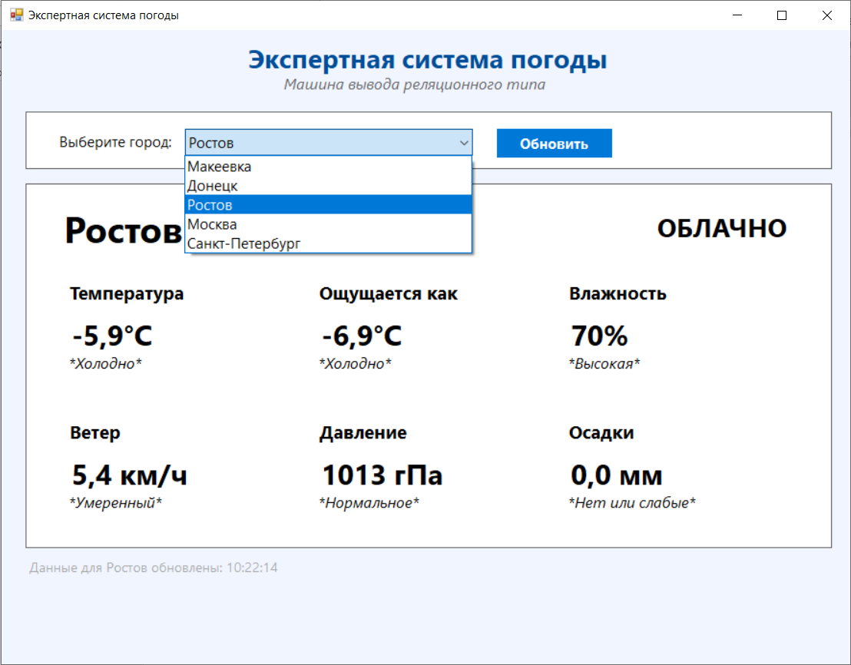
Контрольные вопросы
- Реляционная машина вывода (решатель) — это компонент экспертной системы реляционного типа, который моделирует ход рассуждений эксперта на основании знаний, имеющихся в базе знаний, и реализует процедуру поиска решения задачи: строит цепочку рассуждений (логических выводов), приводящую к конкретному результату.

- Реляционный подход в экспертных системах (реляционные базы данных) имеет несколько преимуществ, которые связаны с обеспечением целостности данных, поддержкой транзакций, удобством запросов и масштабируемостью.
- Эту систему или вообще системы? Если мою, то доверить нормальному человеку, а если вообще понятие системы, то оптимизация и дополнение самой системы.
- Атмосферные явления, Сезонные явления (вероятность гололеда, цунами), Гороскоп.
- Использовать таймер или реактивное обновление по изменению данных.

